Auctioned Order Design: Customer/Firm Order Cancel/CancelReplace Requests

Overview

Current processing
None.

New requirement
This feature handles the Customer/Firm order cancel/cancelReplace requests. Firm order cancel/cancelReplace requests are rejected with NotAccepted exception. Customer order cancel/cancelReplace requests are processed immediately if the order’s internal state is AUCTION_WAITING and are processed on Auction expiration if the order’s internal state is AUCTION_EXPOSING.

Implementation
- Sequence Diagram
The following sequence diagram depicts the process flow for cancel request.

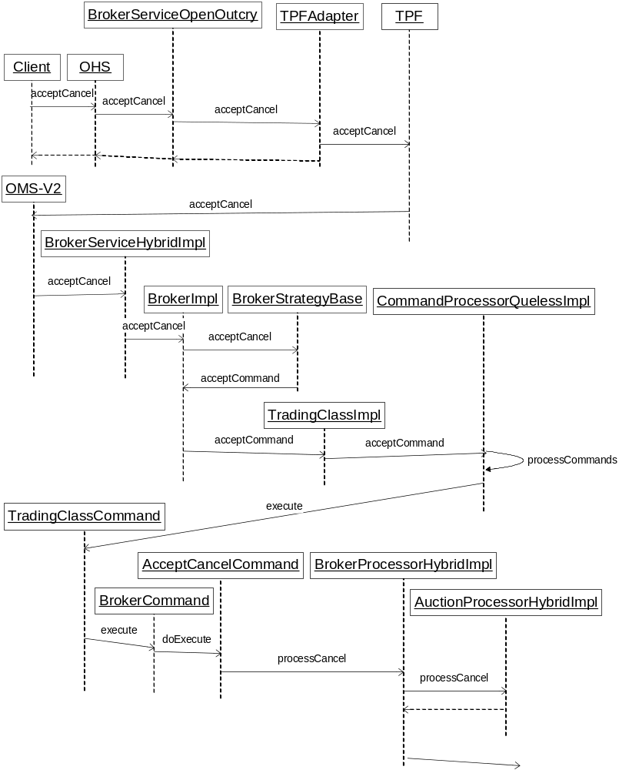

- Order Handling Service
-> OHS.acceptCancel(String userId, CancelRequestStruct cancelRequest, ProductKeysStruct productKeys)
-> OHS.validOrderId(cancelRequest.orderId)
-> OHS.validateProductState(productKeys.productKey)
-> Order order = OHS.findOrderByOrderId(cancelRequest.orderId)
-> If (order.isFirmMatchOrder())
-> {
-> throw ExceptionBuilder.notAcceptedException("Cancel Request for Firm Orders are not allowed. Order ID = " + OrderImpl.orderIdToString(order.getOrderId()), NotAcceptedCodes. INVALID_REQUEST)
-> }
-> acceptCancelByBroker(order, cancelRequest .quantity, cancelRequest .cancelType, cancelRequest.userAssignedCancelId)
-> …
-> …

-> OHS.acceptCancelReplace(CancelRequestStruct cancelRequest, OrderStruct anOrderStruct, LegOrderEntryStruct[] legEntries)
-> OHS.validateProductState(anOrderStruct.productKey)
-> OHS.validOrderId(cancelRequest.orderId)
-> OHS.isValidOrder(anOrderStruct, legEntries, false)
-> originalOrder = OHS.findOrderByOrderId(orderId)
-> …
-> …
-> If (originalOrder.isFirmMatchOrder())
-> {
-> throw ExceptionBuilder.notAcceptedException("CancelReplace Request for Firm Orders are not allowed. Order ID = " + OrderImpl.orderIdToString(originalOrder.getOrderId()), NotAcceptedCodes. INVALID_REQUEST)
-> }
-> replaceOrder = OHS.createNewOrder(anOrderStruct, legEntries, false)
-> …
-> …

- Order Maintenance Service V2
-> OMSv2.acceptCancel(String userId, CancelRequestStruct cancelRequest, ProductKeysStruct productKeys)
-> validateOrderId(cancelRequest.orderId)
-> validateProductState(productKeys.productKey)
-> Order order = findOrderByOrderId(cancelRequest.orderId)
-> If (order.isFirmMatchOrder())
-> {
-> throw ExceptionBuilder.notAcceptedException("Cancel Request for Firm Orders are not allowed. Order ID = " + OrderImpl.orderIdToString(order.getOrderId()), NotAcceptedCodes. INVALID_REQUEST)
-> }
-> …
-> …
-> BrokerServiceHybridImpl.acceptCancel(order, cancelRequest.quantity, cancelRequest.cancelType, cancelRequest.userAssignedCancelId)
-> BrokerImpl.acceptCancel(order, quantity, cancelType, userAssignedCancelId)
-> BrokerStrategyBase.acceptCancel(Broker, order, quantity, cancelType, userAssignedCancelId); // The Actual Strategy object used is BrokerAuctionInternalizedStrategy
-> AcceptCancelCommand.getInstance(order, quantity, cancelType, broker, userAssignedCancelId)
-> BrokerImpl.acceptCommand(AcceptCancelCommand, false)
-> TradingClassImpl.acceptCommand(TradingClassCommand, false)
-> …
-> …
-> AcceptCancelCommand.doExecute()
-> BrokerProcessorHybridImpl.processCancel(order, quantity, userAssignedCancelId)
-> If (order.isAuctionResponse)
-> {
-> processAuctionResponseCancel(anOrder, quantity, userAssignedCancelId)
-> return
-> }
-> this.getOrderBook(order.getProductKey().product.intValue())
-> this.determineShouldRejectCancelRequest(order, quantity, userAssignedCancelId, cancelReason)
-> // Delegate the request to AuctionProcessorHybridImpl
-> if (TradingClassImpl.isAuctionEnabled())
-> {
-> if (!auctionProcessor.processCancel(order, quantity, userAssignedCancelId))
-> return // We are returning here because the order is not in book and hence no need to refresh
-> }
-> forceExpireQuoteTriggerIfInvolved(order.getTradable(),book)
-> …
-> …

-> OMSv2.acceptCancelReplace(CancelRequestStruct cancelRequest, OrderStruct replacementOrder, LegOrderEntryStruct[] legEntryDetails)
-> validateOrderId(cancelRequest.orderId)
-> originalOrder = OMSv2.findOrderByOrderId(originalOrderId)
-> validateProductState(originalOrder.getProductKey().intValue())
-> If (originalOrder.isFirmMatchOrder())
-> {
-> throw ExceptionBuilder.notAcceptedException("CancelReplace Request for Firm Orders are not allowed. Order ID = " + OrderImpl.orderIdToString(originalOrder.getOrderId()), NotAcceptedCodes. INVALID_REQUEST)
-> }
-> …
-> …
-> BrokerServiceHybridImpl.acceptCancelReplace(originalOrder, cancelRequest.quantity, cancelRequest.cancelType, tempOrder, cancelRequest.userAssignedCancelId)
-> BrokerImpl.acceptCancelReplace(originalOrder, quantity, cancelType, replacementOrder, userAssignedCancelId)
-> BrokerStrategyBase.acceptCancelReplace(this, originalOrder, quantity, cancelType, newOrder, userAssignedCancelId)
-> AcceptCancelReplaceCommand.getInstance(order, quantity, cancelType, broker, newOrder, userAssignedCancelId)
-> BrokerImpl.acceptCommand(AcceptCancelReplaceCommand, false)
-> TradingClassImpl.acceptCommand(TradingClassCommand, false)
-> …
-> …
-> AcceptCancelReplaceCommand.doExecute()
-> BrokerProcessorHybridImpl.processCancelReplace(originalOrder, quantity, newOrder,
userAssignedCancelId)
-> …
-> …
-> this.determineShouldRejectCancelReplaceRequest(originalOrder, quantity,newOrder,userAssignedCancelId)
-> this.doCancelReplace(originalOrder,quantity,newOrder,userAssignedCancelId)
-> …
-> …
-> BrokerProcessorHybridImpl.doCancelReplace(originalOrder, quantity, newOrder,
userAssignedCancelId)
-> …
-> …
-> originalOrder.isActive()
-> // Delegate the request to AuctionProcessorHybridImpl
-> if (!auctionProcessor.processCancelReplace(originalOrder, quantity, newOrder, userAssignedCancelId))
-> {
return null;
-> }
-> …
-> …

- Auction Expiration
When the Auction expiration takes place at that point we need to take action on cancel/cancelReplace request for the internalized order if cancel pending.

-> AuctionLocalImpl.expire()
-> setAuctionState(false);
-> …
-> …
-> processCancelRePending()
-> …
-> …
-> AuctionLocalImpl.processCancelRePending()
-> if (this.getAuctionType() == AuctionTypes.AUCTION_INTERNALIZATION)
-> {
-> if (internalizedOrder.isCancelRequestPending())
-> {
-> if (newOrder == null) // Cancel request pending
-> {
-> internalizedOrder.cancel(
-> internalizedOrder.getProductKey().intValue(),
-> pendingCancelQty, tltcQuantity, userAssignedCancelId,
-> internalizedOrder.getMarkedCancelReason(), 0)
-> }
-> else // CancelReplace request pending
-> {
-> internalizedOrder.cancelReplaceWithoutNewOrderReport(
-> pendingCancelQty, newOrder, userAssignedCancelId)
-> // Create ReturnHybridOrderCancelReplaceCommand and put it
-> // in command queue for processing
-> …
-> …
-> }
-> }
-> }

- New Classes and Interfaces

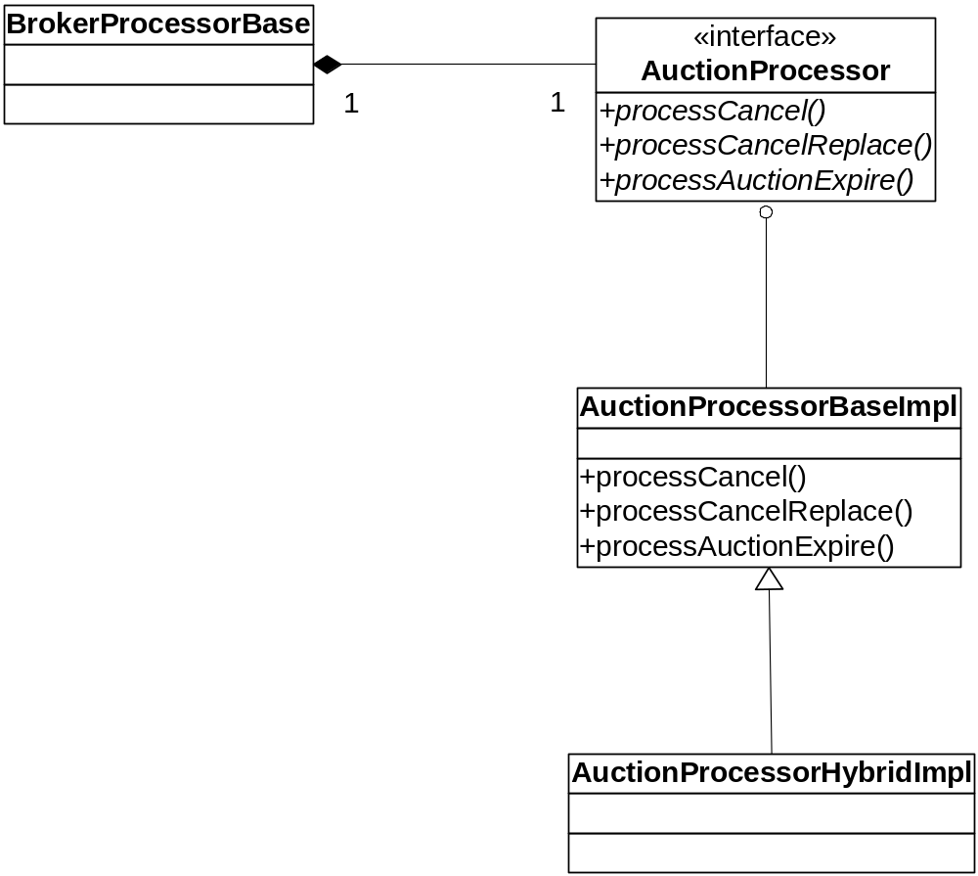

public interface AuctionProcessor
{
public boolean processCancel(Order anOrder, int quantity, String userAssignedCancelId) throws SystemException;
public boolean processCancelReplace(Order originalOrder, int quantity, Order newOrder, String userAssignedCancelId) throws SystemException;
public void processAuctionExpire(Auction theAuction);
}

public class AuctionProcessorBase extends BObject implements AuctionProcessor
{
public boolean processCancel(Order anOrder, int quantity, String userAssignedCancelId) throws SystemException
{
boolean continueProcessing = true;
try
{
// Note: We are not checking to see whether the order is a Firm Order as it is done upfront and there is no way to propagate back errors at this stage

if (anOrder.isInternalizedOrder())
{
if (anOrder.getInternalState() == InternalOrderStates.AUCTION_WAITING)
{
anOrder.cancel(anOrder.getProductKey().intValue(), quantity, userAssignedCancelId, anOrder.getMarkedCancelReason());
continueProcessing = false;
}
else if (anOrder.getInternalState() == InternalOrderStates.AUCTION_EXPOSING)
{
// We have to hold the cancel request till the Auction expires and then cancel
anOrder.setCancelRequestPending(userAssignedCancelId, quantity);
continueProcessing = false;
}
}
}
catch (Exception ex)
{
Log.alarm(this, "AuctionProcessorBase::processCancel - Failed to cancel " + ex.toString());
}
finally
{
}

return continueProcessing;
}

public boolean processCancelReplace(Order originalOrder, int quantity, Order newOrder, String userAssignedCancelId) throws SystemException
{
boolean continueProcessing = true;
try
{
// Note: We are not checking to see whether the order is a Firm Order as it is done upfront and there is no way to propagate back errors at this stage
if (originalOrder.isInternalizedOrder())
{
if (originalOrder.getInternalState() == InternalOrderStates.AUCTION_EXPOSING)
{
// We have to hold the cancelReplace request till the Auction expires and then do cancelReplace
originalOrder.setCancelReplaceRequestPending(userAssignedCancelId, quantity, newOrder);
continueProcessing = false;
}
}
}
catch (Exception ex)
{
Log.alarm(this, "AuctionProcessorBase::processCancelReplace - Failed to cancel " + ex.toString());
}
finally
{
}

return continueProcessing;
}

public void processAuctionExpire(Auction theAuction);
{
}

}

// This class is created as a place holder for future
public class AuctionProcessorHybridImpl extends AuctionProcessorBase
{
}

Scripts
- None

Database

SetContext
- None

XML/DTD

Homes/Services

ImplPlan

PerformanceTestingProcedure

TestingProcedure

OperatorProcedure

Fallback/Failover

